**BAN 5753**

**ADVANCED BUSINESS ANALYSIS**

**MINI PROJECT 2**

GitHub link : <https://github.com/NaveenKrRai/BAN5753-MiniProject>

**TEAM - LAMDA**

Srujana Talla

A

A

Gowtham Bhupathiraju

A

A

Kodjo Opoku Botchway

Naveen Kumar Rai

A

A

**Business Problem**

We are given the dataset of XYZ bank’s direct marketing campaign. We have to work on the following problems:

* 1. The objective of the classification is to identify clients who will subscribe (yes/no) for a term deposit. (Variable y: Target function).
  2. The Bank wants us to conduct Exploratory Data Analysis (EDA) to identify relationships, and trends in data. For example correlations, bivariate analysis of target versus input variables, facts, univariate patterns, missing data.
  3. Prescriptive recommendations
  4. K-means Clustering.
  5. Compare more than four different supervised algorithms

**Dataset Information:**

* Data is about an XYZ bank’s direct marketing campaign. Marketing campaigns were driven by telephone calls.
* Data Set In many cases, more than one contact for the same client was required., in order to access if the product (deposit) would be ('yes') or not ('no') subscribed
* The purpose of the classification is to forecast whether the customer will signup (yes/no) a term deposit (variable y).
* The dataset: XYZ_Bank_Deposit_Data_Classification.csv, 20 entries/columns, sorted by date between May 2008 and November 2010.

**Our Approach:**

**Exploratory Data Analysis**

* Read the data

* Rename the columns

* Displays the Data frame

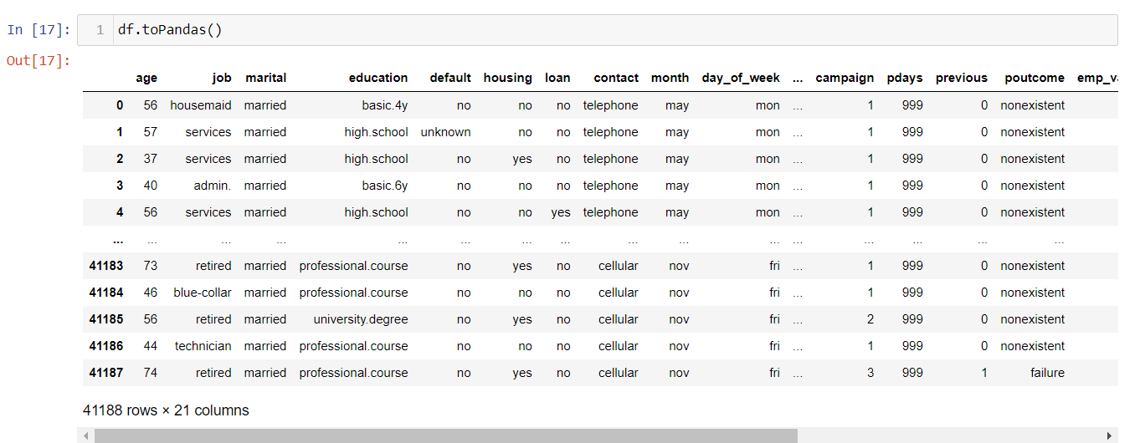

**Summary Statistics:**

**Schema:**

**Missing Data:**

* We did not find any missing values in the data

**Numeric Features:**

* There are a total of 10 numeric variables in the data set

* Univariate Patterns of the Numeric variables

From the patterns we can observe that the is not normal distribution of these variables. Most of them are skewed to the left and we can also see few BiModal distributions

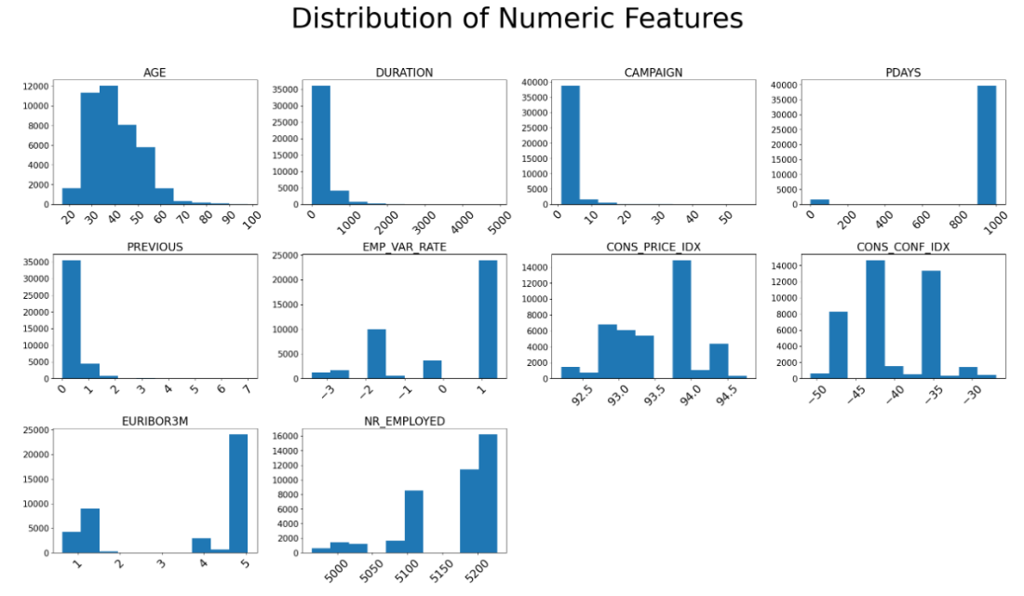

* Correlations between Numeric Features

* The variables emp_var_rate and euribor3m have the highest correlation.

**Categorical Features:**

* We have a total of 11 categorical variables of which y is the target variable
* Below snippet explains the distinct values in each of the categorical variable

* Univariate Patterns of the categorical variables

**Bivariate Analysis of Target vs Input Variables:**

**Modelling**

* Split the data into 80% train and 20% test data.

* Preprocessing like – String Indexing, Standard Scaler and Vector Assembler

* Train and test data set with the processed features

**Predictive Model 1- Logistic Regression**

* The first classification model is Logistic Regression. Below are the predictions from the model

**Confusion Matrix:**

* The True Positives is 400 and True Negatives is 7170 = 7570
* The False Positives is 182 and False Negative is 542 = 724

**Model Accuracy: 91.27%**



**ROC Curve:**

**Test AUC: 93.85%**

**Predictive Model 2 – Decision Tree**

* The second classification model is Decision Tree - classifier. Below are the predictions from the model

**Confusion Matrix:**

* The True Positives is 517 and True Negatives is 7098 = 7615
* The False Positives is 254 and False Negative is 425 = 679

**Model Accuracy: 91.81%**

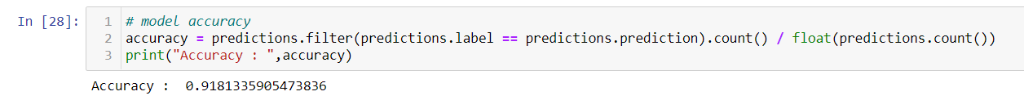

**ROC Curve:**

**Test AUC: 91.87%**



**Predictive Model 3 – Random Forest**

* The Third classification model is Random Forest - classifier. Below are the predictions from the model

**Confusion Matrix:**

* The True Positives is 161 and True Negatives is 7319 = 7480
* The False Positives is 33 and False Negative is 781 = 814

**Model Accuracy: 90.185%**



**ROC Curve:**

**Test AUC: 92.76%**

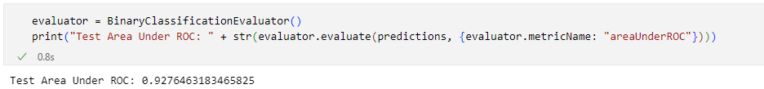

**Predictive Model 4 – Gradient Boosting**

* The Fourth classification model is Gradient Boosting - classifier. Below are the predictions from the model

**Confusion Matrix:**

* The True Positives is 501 and True Negatives is 7110 = 7611
* The False Positives is 242 and False Negative is 441 = 683

**Model Accuracy: 91.76%**

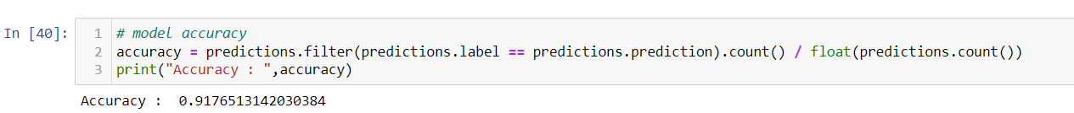

**ROC Curve:**

**Test AUC: 94.74%**



**Champion Model**

|  |  |  |
| --- | --- | --- |
| **Model Name** |  | **Test AUC Value** |
| Logistic Regression |  | 0.9385 |
| Decision Tree |  | 0.9186 |
| Random Forest |  | 0.9276 |
| Gradient Booster |  | 0.9474 |

* On comparing the four models **Gradient Boosting** has the best Model accuracy of – 91.76%, True Positives and Negatives of 7611 and Test AUC of 94.74%.
* Hence, we choose this model as our best model for classification of identify clients who will

subscribe (yes/no) for a term deposit.

* Here are the top 10 Important Features of our Gradient Boosting Model

**K Means Clustering**

* We clustered the given customers into 5 clusters based on the features.

* Maximum number of clusters are in the group 0 followed by group 2

* In cluster 0 most customers are single and have basic or high school education. They usually are admins and blue collared employees.

* In cluster 1 most customers are married or divorced and have a university degree education. They usually are admins.

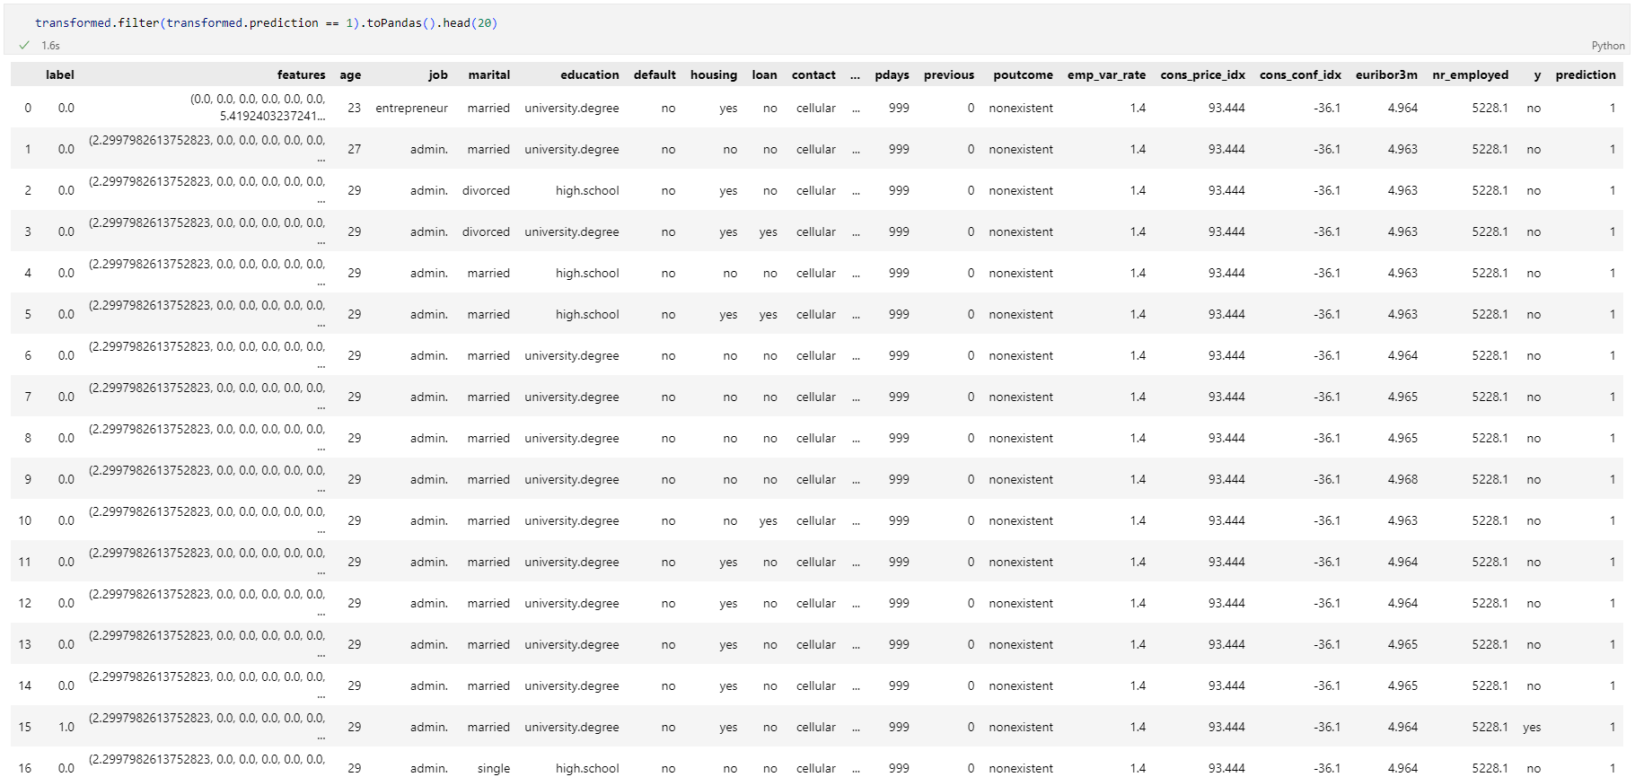

* In cluster 2 most customers are single and have a basic or high school education. They usually are mostly students.

* In cluster 3 most customers are single or divorced and have a high school education. They usually are mostly students and technicians.

* In cluster 4 most customers are single and have a university or professional education. They usually are working people who use the telephone.

**Our Recommendations**

* Since most of the customers for the bank lie in the age group 30-50, educating this age group will be more beneficial to make them sign up for term deposit.
* Contact duration less than 2000 seconds will be beneficial in conversion of clients.
* Contacting less than 20 times during the campaign for a particular customer would end the bank with a high number of clients subscribing for term deposit.
* Clients who don’t have credit are the target segment.
* Most of the clients are people with a job – admins, Blue-collared, service.
* May is the month of most conversion – focus should be laid around that duration.
* From the Prediction Model we also see that duration, Number of employees, age, cons_conf_idx, campaign are the top features for prediction. Working on them would yield better results.